# Keeping up to date

## Introduction

Now you have seen what the sensorlist is capable of, you might have guessed that the sensorlist is the spill of the system. From the first build, up to changing large amount of data, the sensorlist is the tool for working with NavVision.

It is very important that you keep the sensorlist up to date during commissioning. The best way to do this is probably have the sensorlist open at your laptop and change immediately everything that you change in NavVision on board. We know that it is sometimes very hectic and you don’t have the time to do this directly. In that case it’s best that you change it right after you finished your days’ work. This way you can use the sensorlist the next day again.

We will explain here the different methods of keeping the sensorlist up to date.

## Direct changing

So this is the one that you keep the latest sensorlist open at your laptop, next to the workstation that you are working on. When you alter something directly on the workstation, you can immediately change that in the sensorlist.

I already gave an example in Chapter 11.5 with the crew names. But now lets say that you are working on the workstation and you find out that the serialnetwork on moxa 1 port 1 has a different baudrate. The seriallan is the 1st one in the ER en you have to change port 1 to a baudrate of 38400 instead of 115200. In NavVision you change this on the workstation and the connection seems to be good.

Next time you import the sensorlist, you might wonder why the port isn’t working anymore. This is why you need to change it in the sensorlist in the tab “devicelist” to make sure next time the import will be in order. So go to your laptop, click on the devicelist tab and change the baudrate accordingly (see Figure 13‑1 and Figure 13‑2).



Figure 13‑1: changing baudrate old



Figure 13‑2: Changing baudrate new

Same goes for the changes in the sensorlist. Again you’re working on the workstation and you notice that you have to change a connection at the Wago. It seems that the connections on the Wago Workshop are switched. The sensor on pin 3 is on pin 5 and the sensor on pin 5 is on pin 3. Of course you can change the wires on the Wago itself but for argument sake we say that you change the fieldnames in the Wago-section of the workstation.

Again you need to change this in the sensorlist or it will get back to the old state as you import the sensorlist again. The original lines you will find in the next figure:



Figure 13‑3: Changing Wago original

Now you can switch the whole line with names, fields and everything (see Figure 13‑4). Realize that you still need to change the pin-number, or nothing will change. For readability this will be the best option and also if you have to change a lot of pin numbers this is more synoptic. There will be an example later.



Figure 13‑4: Changing Wago lines

If it is about small amounts of changes it is easier to just change the pin-number. NavVision doesn’t mind and will put it in the right order into the system. See next figure:



Figure 13‑5: Changing Wago numbers

### insert

When you need to insert a new connection into the Wago (an extra sensor for example), it could be very easy to do as you can read in the “Installation and commissioning manual”. Just choose a free pin in NavVision Tools>Configuration>Wago. However, don’t forget to put that also in the sensorlist or you will lose that connection again after importing.

Same goes for extra devices in the “devicelist” tab. Just remember: importing a sensorlist will overwrite every change you have made on the system.

## Bigger changes

One of the bigger changes that can take place is that you have to change the order of the Wago slices or you will have to add a Wago slice somewhere. This will mess up the whole configuration. Without using the sensorlist this is almost impossible to do.

Let’s pretend you have the following configuration:

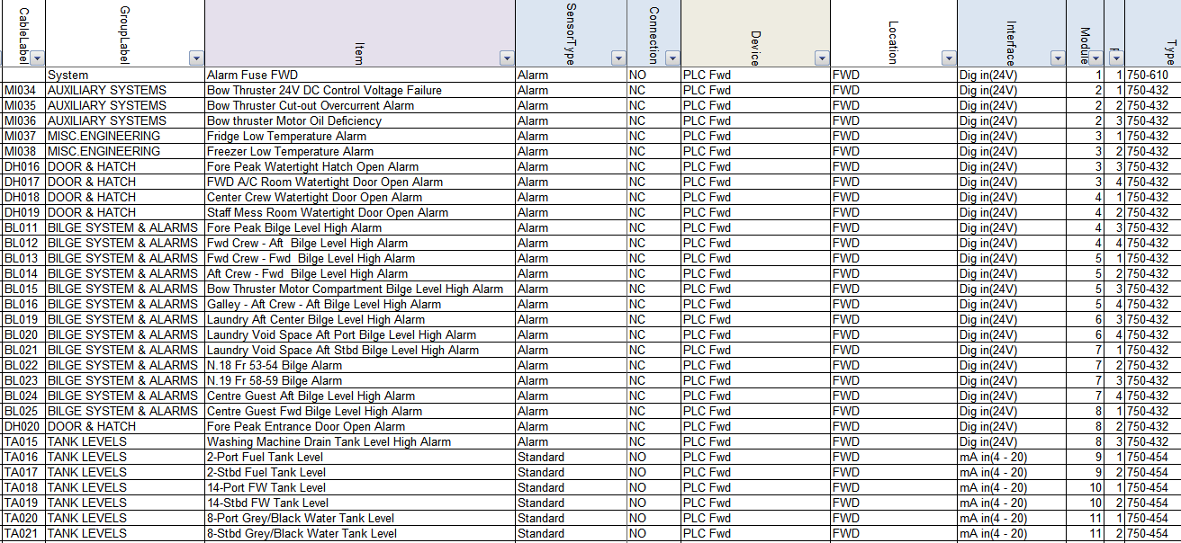

Figure 13‑6: Inserting a Wago slice 1

Now you need to put an extra slice (DI) 750-432 after the 3rd slice in the Wago. If you do that NavVision will see that as a slice without a number and all the fields after slice 3 will go back one slice. You can imagine that is not what we want.

Now let’s do this with the sensorlist. You insert an empty row after the 3rd slice (see Figure 13‑7). Now this will be the 4th slice so at the module column you say it is number 4 and you fill in all the other appropriate fields (see Figure 13‑8).

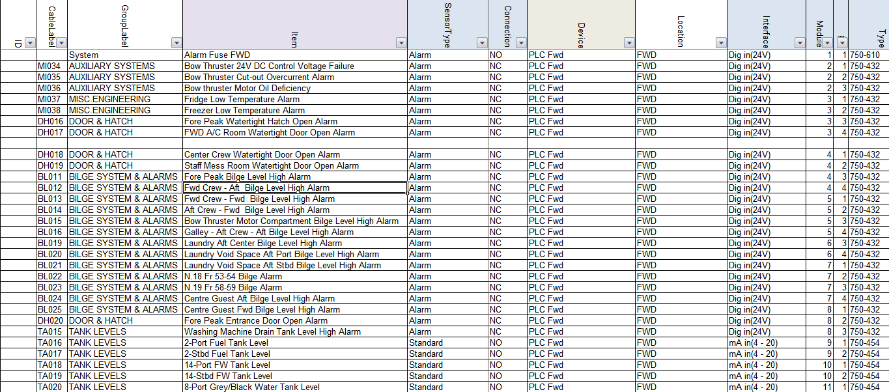

Figure 13‑7: Inserting a Wago slice 2

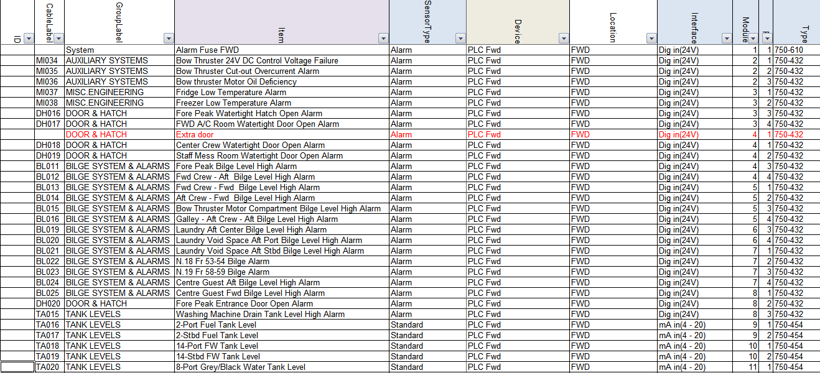

Figure 13‑8: Inserting a Wago slice 3

Now you will have two Wago slices with number 4 so you will need to increase the rest of the module numbers on that Wago. Of course you can do this by hand, but Excel is very helpful in this. Just find a cell with number 1 in it (cause we need to increase the modules by 1) an click CTRL-C to copy the number. Now select all the select all the cells in the module-column that need to be adjusted and right-click. Select “Paste Special” (see Figure 13‑9).

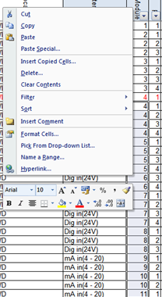

Figure 13‑9: Excel trick 1

In the next window choose “Add” and then click OK (see Figure 13‑10). You will see that all the module numbers has increased by 1.

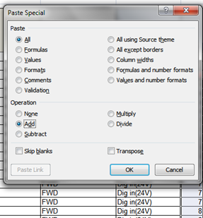

Figure 13‑10: Excel trick 2

Now you can easily import the sensorlist (after you inserted the new Wago slice) and it will set everything in its right place.

## Keep the sensorlist up to date afterwards

### Introduction

Most likely you will find yourself occupied with work or you will get on board and the crew has made a lot of changes. In both cases it is impossible to use the sensorlist because it probably makes more problems than that it serves you. In that case you need to clean up the sensorlist first. After the clean-up you can use the sensorlist again.

To clean up the sensorlist you need to follow the instructions below. This is, for now, the best way to do this. The bigger the sensorlist is and the more changes, the more time-consuming it will be. But in the end you will only benefit.

### What do you need

You need a complete clean installation of the latest NavVision on your pc/laptop. Keep this one clean and copy your key file (the *.key.ini) into the folder NavVision/config/network.

If you start at a new project, or wish to make a new beginning, make a new folder and name it after your project. Copy al the files from the clean NavVision folder into your new folder. You will get the following folder:

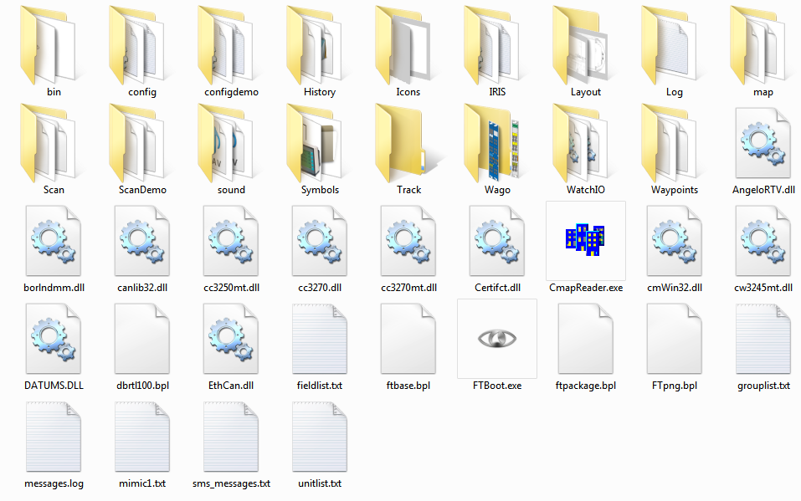

Figure 13‑11: clean NavVision folder

Also you need the config-folder from the installation on board (better back-up the whole NavVision folder). You can do this at the end of the day, when you have finished working on the system, or at a ship that you arrive at for commissioning.

### Cleaning up after a day on board

After you have been on board all day we assume that you have made a backup of the system. Now you do have an existing sensorlist, but we need to find out the changes. Here are the steps you need to take.

#### Copy devicelist.dat and sensorlist.dat

In the backup you took with you from aboard you find two files in the folder NavVision/config/network. These files are:

* Devicelist.dat
* Sensorlist.dat

Now copy these files and paste then in the folder NavVision/config/network of the folder you made on your pc/laptop as in Figure 13‑11. This folder now contains the configuration on board as it was when you left. Don’t start up yet.

#### The old sensorlist

You also have the old sensorlist.xls that you had before you went on board. If you do not already have the file as described, but only the raw sensorlist, we refer you to Chapter 9.4 to see how to save a sensorlist for import.

Copy this sensorlist.xls in to the root of your project folder. It will now look as follows:

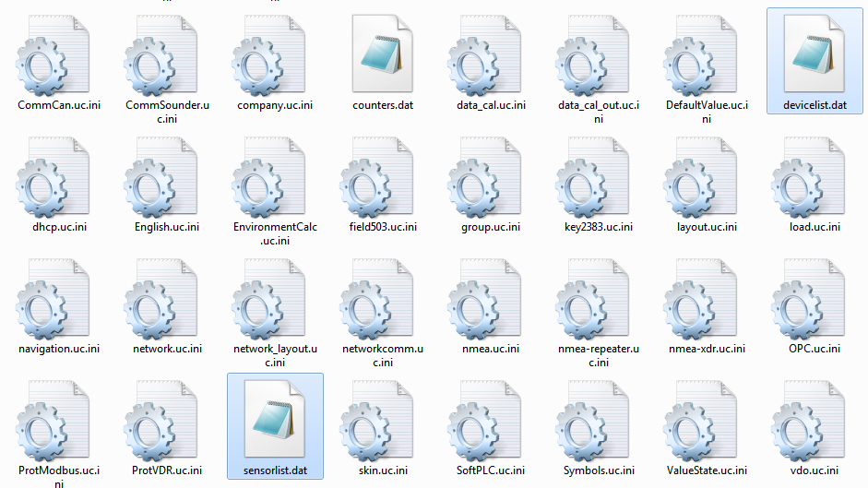

Figure 13‑12: Devicelist.dat and sensorlist.dat in network folder

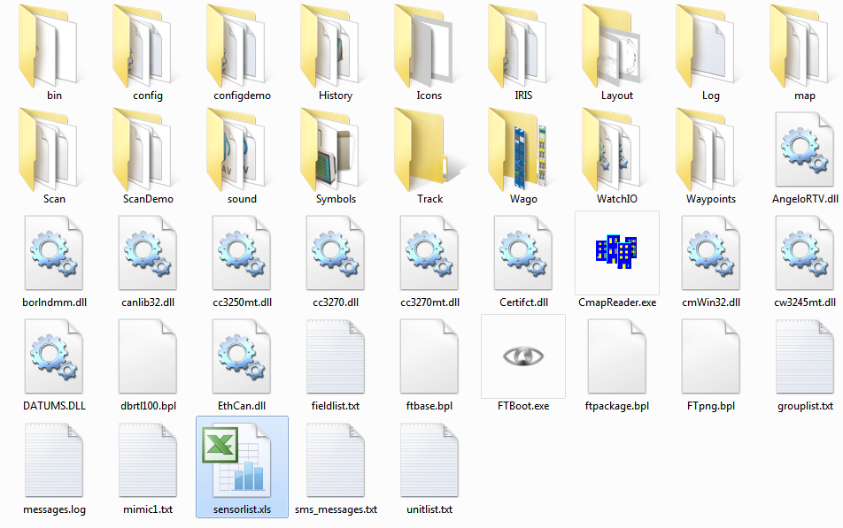

Figure 13‑13: sensorlist.xls in root of project folder

#### Startup your project folder

Now you must start up the NavVision that is in your project folder. To do so, go to the folder NavVision/bin and double-click the NavVision.exe. This way you know that you start the right version.

During startup NavVision will ask you if you want to import the devicelist and after that the sensorlist. Answer both questions with “Yes”. NavVision will start up completely.

After it started up you can shut it down immediately. NavVision will now generate de devices you need. These are:

* devicelist_generated.html
* sensorlist_generated.html
* sensorlift_generated_diff.html

These files can be found in the root of your projectfolder which now looks like the following:

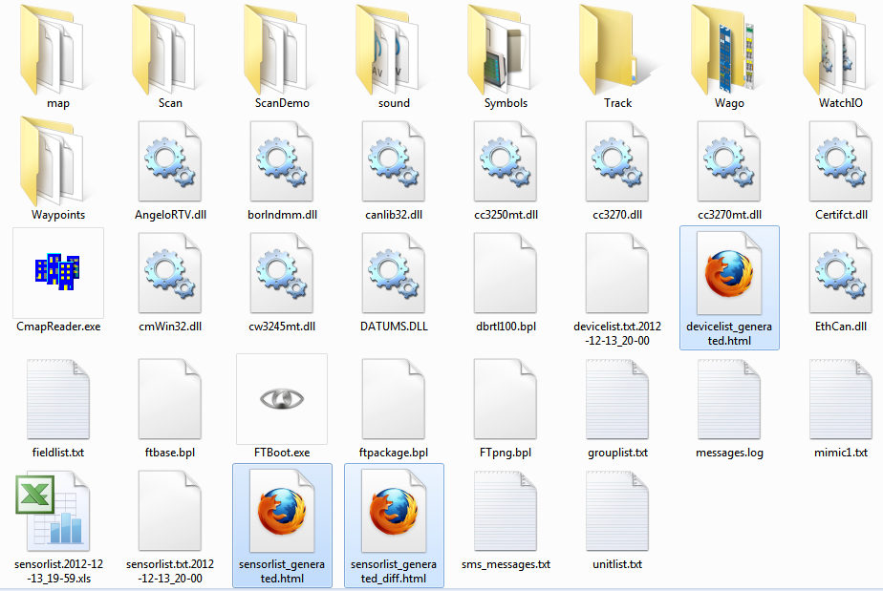

Figure 13‑14: root folder after import sensorlist